By Friday 1st October – Energy Efficiency Week 2021
Copy and paste the table and contents below into and email.
Please be aware that if you use these templates, we will not be able to provide you with any statistics on the level of engagement from staff in your building. Please also be aware that some of the content linked to will not become live until the day of release.

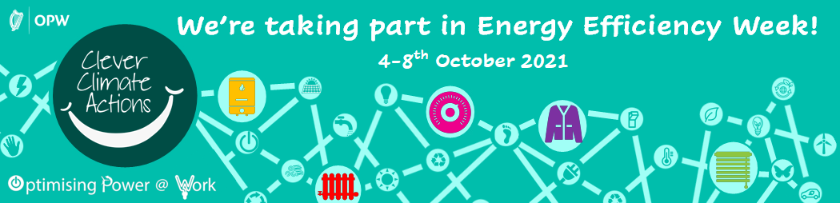

Countdown to Energy Efficiency Week!

Dear Colleagues,
We're taking part in Energy Efficiency Week!
The focus of this week-long event is on Clever Climate Actions that can save energy, reduce carbon emissions and help protect our wonderful world.
Each day sees a different topic explored, with three levels of energy saving actions, that will help you keep warm as winter draws near and make a positive impact on your carbon footprint.
I encourage you to take part in the online activities and explore the Clever Climate Actions. These small but important actions all add up to make a world of difference.

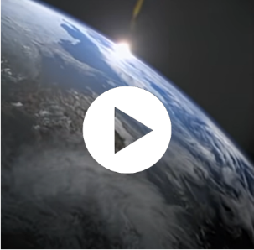
To establish the mood, this short YouTube video offers brilliant footage of the absolute beauty of our natural world. These powerful images are accompanied by the voice of broadcaster and naturalist David Attenborough speaking the timeless lyrics of the Louis Armstrong song "What a Wonderful World."
Enjoy!

Best regards,
The Energy Team

Connect to our Clever Climate Actions Campaign.

